LOS VERDES MEN’S GOLF CLUB
Bus Trips
Los Serranos 36 Holes
Friday August 5, 2022 $140
OLD MAN ENDUARNCE TOURNAMENT
Moorpark Country Club
Sunday September 18, 2022 $140
RYDER CUP
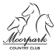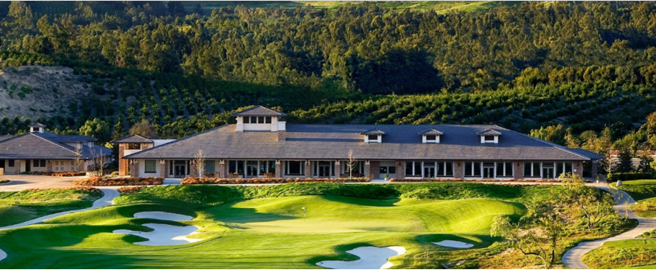
Glen Ivy Golf Club
Road Trip
Saturday November 5, 2022 $144
Contact Bus Chairman – Tino Gomez tino.gomez@infineon.com
310-650-3124

